Hill Stations:

Nathia Gali

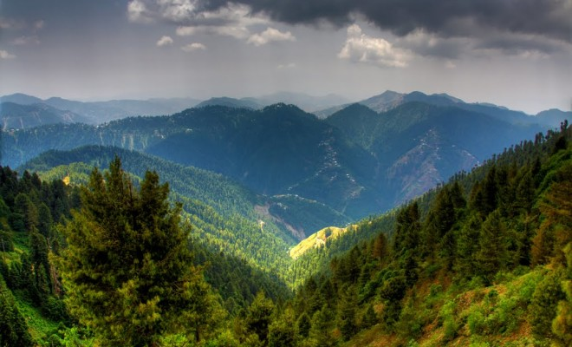

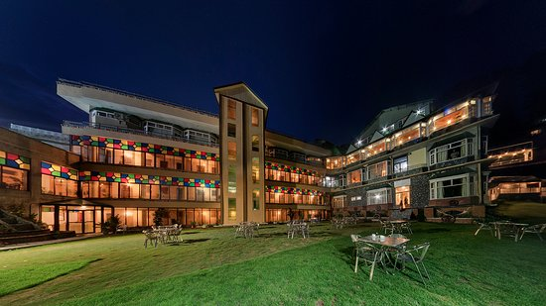

**Nathia Gali** or **Nathiagali** is a mountain resort town or hill station in Abbottabad District of Khyber Pakhtunkhwa, Pakistan. It is located at the center of the Galyat range, where several hill-stations are situated, closely connected to each other, and with their names mostly ending in 'Gali'. Nathiagali is known for its scenic beauty, hiking tracks and pleasant weather, which is much cooler than the rest of the Galyat due to it being at a greater altitude. It is situated 32 kilometers at one hour's drive away from both Murree and Abbottabad, lying midway between these two places. The drive time from Islamabad is usually about three hours, unless there is a lot of traffic.